**Pizza Sale SQL Queries**

KPI’s

1. Total Revenue-

select round(SUM(total_price),3) as Total_Revenue from pizza_sales;

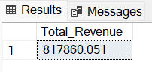

1. Average order value

select ROUND((SUM(total_price) / COUNT(Distinct order_id)),3) as Avg_Order_Sale from pizza_sales;

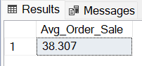

1. Total Pizza sold

select SUM(quantity) as Total_Pizza_Sold from pizza_sales;

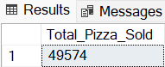

1. Total Order placed

select COUNT(Distinct order_id) as Total_Order from pizza_sales;

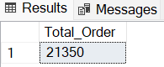

1. Average Pizza per order

select CAST((CAST(SUM(quantity) as decimal(10,3)) / CAST(COUNT(Distinct order_id) as decimal(10,3))) AS decimal(10,3)) as Avg_Pizza_per_Order from pizza_sales;

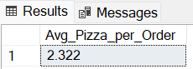

Chart Requirements-

1. Daily Trend for Total Orders

select DATENAME(dw,order_date) as "Day",

COUNT(Distinct order_id) as "Total_orders"

from pizza_sales

group by DATENAME(dw,order_date);

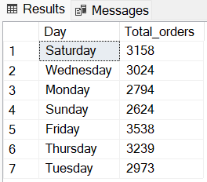

1. Hourly Trends for Total Order-

select DATEPART(HH,order_time) as order_hour,

COUNT(Distinct order_id) as Total_hour

from pizza_sales

group by DATEPART(HH,order_time)

order by DATEPART(HH,order_time);

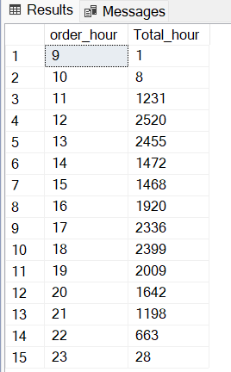

1. Percentage sale by Pizza category-

select pizza_category,

Round(100*(sum(total_price)/(select sum(total_price) from pizza_sales)), 3) as category_percentage

from pizza_sales

group by pizza_category

order by category_percentage desc;

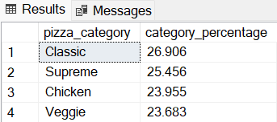

1. Percentage of sale by Pizza size

select pizza_size,

Round(100*(sum(total_price)/(select sum(total_price) from pizza_sales)), 3) as size_percentage

from pizza_sales

group by pizza_size

order by size_percentage desc;

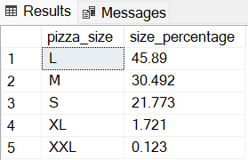

1. Total pizza sold by category

select pizza_category, count(quantity) as Pizza_Count

from pizza_sales

group by pizza_category

order by Pizza_Count desc;

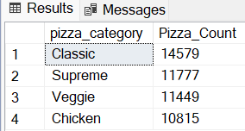

1. Top 5 best seller by Total pizza sold

select TOP 5 pizza_name,

sum(quantity) as total_quantity

from pizza_sales

group by pizza_name

order by sum(quantity) desc;

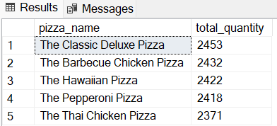

1. Bottom 5 worse seller by total pizza sold

select TOP 5 pizza_name,

sum(quantity) as total_quantity

from pizza_sales

group by pizza_name

order by sum(quantity);

